Lab-9
Question 9:
• Prepare screen list
Solution:
Screen-1: User Login Form
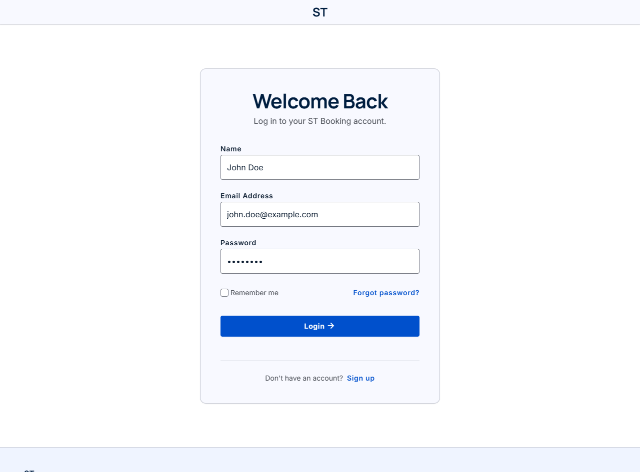

Figure 3.1: Screen-1: User Login Form
Sr. | Screen Element | Input Type | O/M | 1/N | Description
1 | Name | Textbox | M | 1 | Accept user's full name
2 | Email Address | Textbox | M | 1 | Accept user email address for authentication
3 | Password | Password | M | 1 | Accept account password
4 | Remember me | Checkbox | O | 1 | Retain user login session
5 | Forgot password? | Link | O | 1 | Navigate to password reset screen
6 | Login button | Button | M | 1 | Authenticate credentials and log into dashboard
7 | Sign up link | Link | O | 1 | Navigate to user registration page

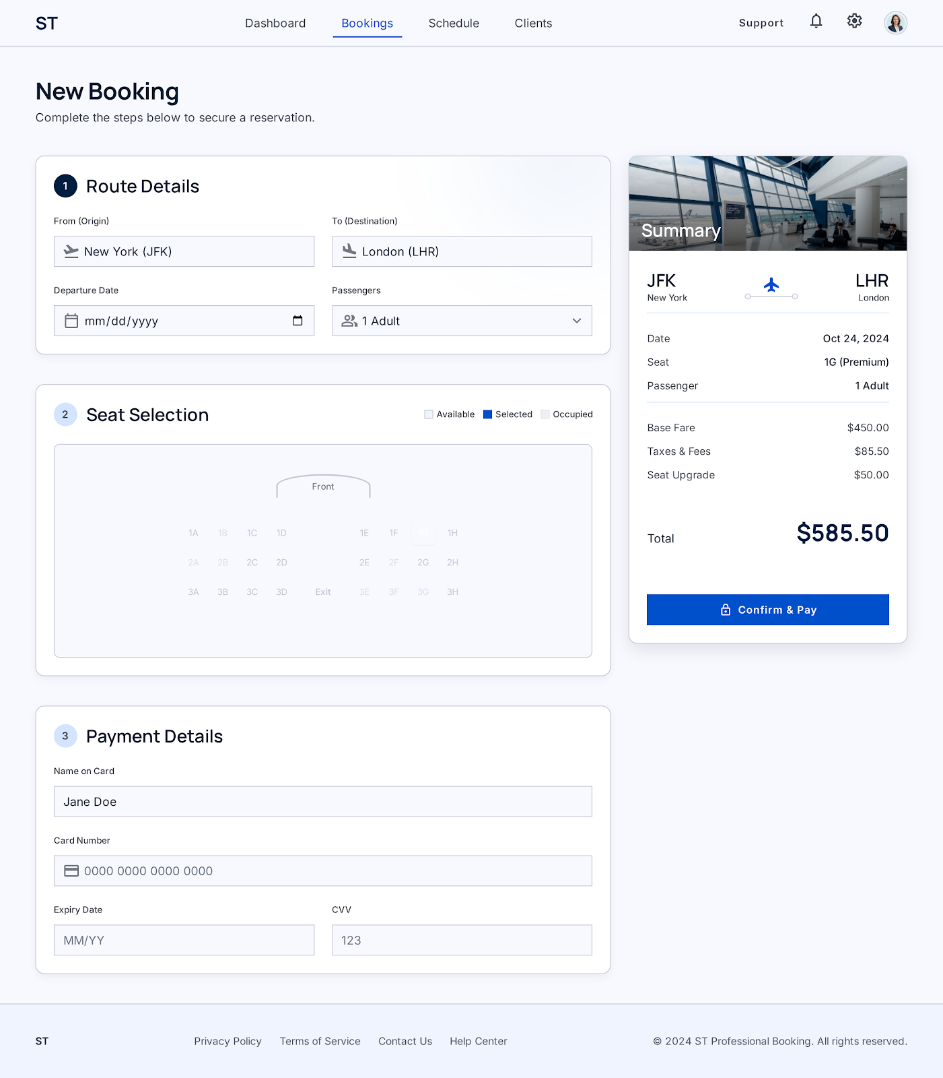

Figure 3.2: Screen-2: TICKET BOOKING FORM

Sr. | Screen Element | Input Type | O/M | 1/N | Description
1 | From (Origin) | Textbox / Dropdown | M | 1 | Select departure airport / city (e.g., JFK)
2 | To (Destination) | Textbox / Dropdown | M | 1 | Select destination airport / city (e.g., LHR)
3 | Departure Date | Date Picker | M | 1 | Select scheduled departure travel date
4 | Passengers | Dropdown | M | 1 | Select passenger count and category (e.g., 1 Adult)
5 | Seat Selection Map | Interactive Map | M | 1 | Select specific seat on aircraft/coach layout (e.g., 1G)
6 | Name on Card | Textbox | M | 1 | Accept cardholder's full name
7 | Card Number | Textbox | M | 1 | Accept 16-digit debit / credit payment card number
8 | Expiry Date | Textbox | M | 1 | Accept card expiration date in MM/YY format
9 | CVV | Textbox | M | 1 | Accept 3/4-digit card security code
10 | Confirm & Pay | Button | M | 1 | Process transaction and generate confirmed booking

Screen-3: Appointment booking form
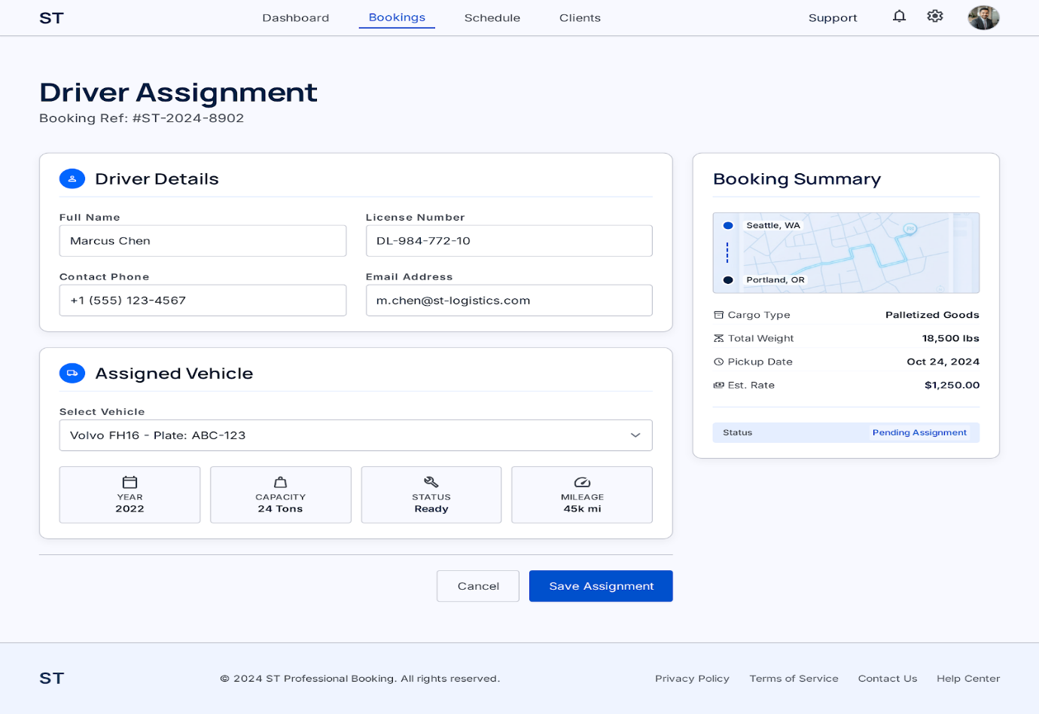

Figure 3.3: Screen-3: DRIVER ASSIGNMENT FORM

Sr. | Screen Element | Input Type | O/M | 1/N | Description
1 | Full Name | Textbox | M | 1 | Display/accept assigned driver's full legal name
2 | License Number | Textbox | M | 1 | Display/accept commercial driver's license number
3 | Contact Phone | Textbox | M | 1 | Display/accept driver's primary contact phone number
4 | Email Address | Textbox | M | 1 | Display/accept driver's official email address
5 | Select Vehicle | Dropdown | M | 1 | Choose assigned transit vehicle / fleet unit
6 | Cancel button | Button | O | 1 | Dismiss driver assignment process
7 | Save Assignment | Button | M | 1 | Save and commit driver and vehicle assignment

Screen-4: Appointment booking form
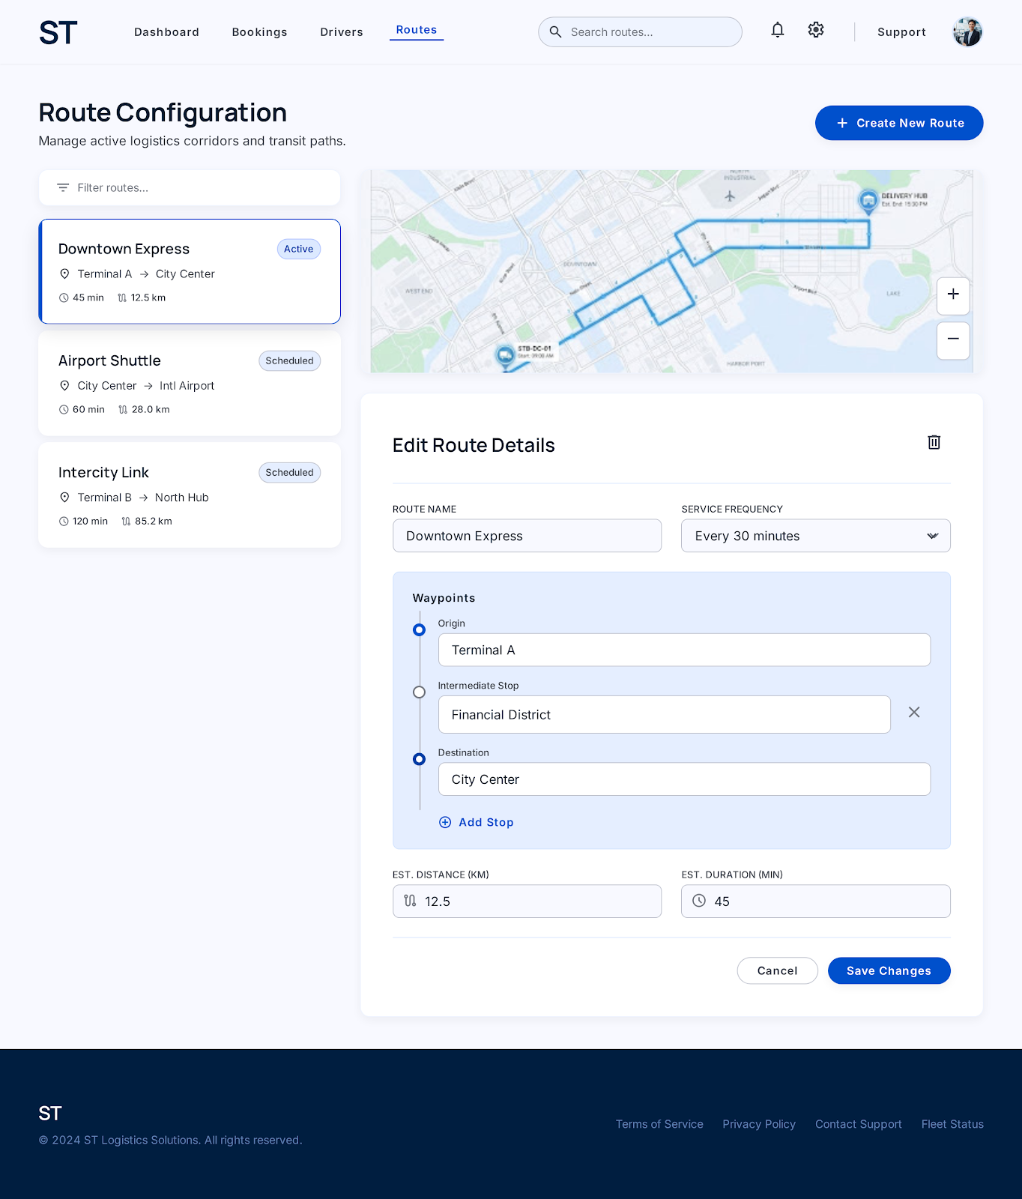

Figure 3.4: Screen-4: ROUTE CONFIGURATION FORM

Sr. | Screen Element | Input Type | O/M | 1/N | Description
1 | Create New Route | Button | O | 1 | Open new transit corridor creation form
2 | Route Name | Textbox | M | 1 | Specify route identifier (e.g., Downtown Express)
3 | Service Frequency | Dropdown | M | 1 | Define dispatch frequency interval (e.g., Every 30 mins)
4 | Origin Waypoint | Textbox | M | 1 | Set primary starting terminal/location
5 | Intermediate Stop | Textbox | O | N | Add intermediate transit pickup/drop stops
6 | Destination Waypoint | Textbox | M | 1 | Set final destination hub
7 | Add Stop button | Button | O | 1 | Insert additional waypoint stop field
8 | Est. Distance (KM) | Textbox | M | 1 | Input total route travel distance in KM
9 | Est. Duration (MIN) | Textbox | M | 1 | Input estimated journey duration in minutes
10 | Delete Route | Button | O | 1 | Remove selected route configuration
11 | Cancel button | Button | O | 1 | Discard route modifications
12 | Save Changes | Button | M | 1 | Update and apply route configuration

• Prepare database schema
  - List of Tables

2 Product view Database design

2.1 List of Tables
- UserAccount
- Song
- Playlist
- Artist Profile

Table 4.1: Table: UserAccount

Column | Data Type | Null | Keys & Constraints | Default Value & Description
UserID | INT | NN | PK (Auto Increment) | Unique system user identifier
FullName | VARCHAR(100) | NN | - | User legal / registered full name
EmailAddress | VARCHAR(150) | NN | UNIQUE | Login email address for authentication
PasswordHash | VARCHAR(255) | NN | - | Secure encrypted account password
Role | VARCHAR(50) | NN | - | User type selector (Admin, Driver, Passenger)
CreatedAt | TIMESTAMP | NN | - | DEFAULT CURRENT_TIMESTAMP (Registration timestamp)

Table 4.2: Table: Route
Column | Data Type | Null | Keys & Constraints | Default Value & Description
RouteID | INT | NN | PK (Auto Increment) | Unique transit route identity code
RouteName | VARCHAR(150) | NN | - | Corridor name (e.g., Downtown Express)
Origin | VARCHAR(150) | NN | - | Departure origin terminal / station
Destination | VARCHAR(150) | NN | - | Arrival destination terminal / hub
ServiceFrequency | VARCHAR(50) | NN | - | Departure interval (e.g., Every 30 mins)
DistanceKM | DECIMAL(6,2) | NN | - | Total route travel distance in kilometers
EstDurationMin | INT | NN | - | Estimated journey duration in minutes

Table 4.3: Table: Vehicle
Column | Data Type | Null | Keys & Constraints | Default Value & Description
VehicleID | INT | NN | PK (Auto Increment) | Internal fleet vehicle identifier
VehicleModel | VARCHAR(100) | NN | - | Vehicle make & model (e.g., Volvo FH16)
PlateNumber | VARCHAR(50) | NN | UNIQUE | Official registration license plate code
ModelYear | INT | NN | - | Vehicle manufacturing year
CapacityTons | DECIMAL(5,2) | NN | - | Carrying / payload capacity in tons
MileageKM | INT | NN | - | DEFAULT 0 (Total recorded mileage)
Status | VARCHAR(50) | NN | - | DEFAULT 'Ready' (Ready, In Transit, Maintenance)

Table 4.4: Table: Driver
Column | Data Type | Null | Keys & Constraints | Default Value & Description
DriverID | INT | NN | PK (Auto Increment) | Unique driver record identification
FullName | VARCHAR(100) | NN | - | Full legal driver name
LicenseNumber | VARCHAR(50) | NN | UNIQUE | Commercial driver's license number
ContactPhone | VARCHAR(20) | NN | - | Driver primary contact telephone number
EmailAddress | VARCHAR(150) | NN | UNIQUE | Official driver email address
AssignedVehicleID | INT | AN | FK -> Vehicle(VehicleID) | Foreign key referencing assigned fleet vehicle

Table 4.5: Table: Booking
Column | Data Type | Null | Keys & Constraints | Default Value & Description
BookingID | INT | NN | PK (Auto Increment) | Primary key ticket booking identifier
BookingRef | VARCHAR(50) | NN | UNIQUE | Formatted reference code (e.g., #ST-2024-8902)
UserID | INT | NN | FK -> UserAccount(UserID) | Reference to customer user account
RouteID | INT | NN | FK -> Route(RouteID) | Reference to scheduled transit route
DriverID | INT | AN | FK -> Driver(DriverID) | Reference to allocated transit driver
TravelDate | DATE | NN | - | Scheduled date of travel
SeatNumber | VARCHAR(10) | AN | - | Assigned seat code (e.g., 1G)
TotalAmount | DECIMAL(10,2) | NN | - | Total billing amount (Fare + Taxes + Upgrades)
PaymentStatus | VARCHAR(50) | NN | - | DEFAULT 'Pending' (Paid, Pending, Failed)
BookingStatus | VARCHAR(50) | NN | - | DEFAULT 'Pending Assignment' (Assigned, Completed)

